|  |  |  |
| --- | --- | --- |
| Soy  Soy with solid fill  Soy  Soy with solid fill |  |  |
| Tree Nuts  Acorn with solid fill | Tree Nuts  Acorn with solid fill |
| Wheat  Crops outline | Wheat  Crops outline |
| Gluten  Grain with solid fill |  |
| Sulfites  Chemicals with solid fill | Sulfites  Chemicals with solid fill |

Gluten



|  |  |  |
| --- | --- | --- |
| Crustacean Shellfish  Crab with solid fill |  | Crustacean Shellfish  Crab with solid fill |
| Eggs  Egg with solid fill | Eggs  Egg with solid fill |
| Fish  Fish with solid fill | Fish  Fish with solid fill |
| Milk  Dairy with solid fill | Milk  Dairy with solid fill |
| Peanut  Nuts with solid fill | Peanut  Nuts with solid fill |
|  |  |  |

Lupin



Lupin



Sesame



Sesame



Mustard



Mustard



Molluscan Shellfish



Molluscan Shellfish



Tree Nuts



Tree Nuts



Wheat

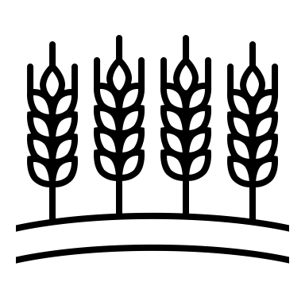

Wheat



Gluten



Gluten



Sulfites

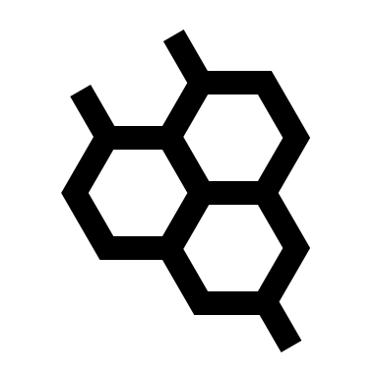

Sulfites



Celery



Celery

